|  |
| --- |
| **Session 2 Worksheet** |

## Exercise 1

Create a login form according to the requirements as shown below.

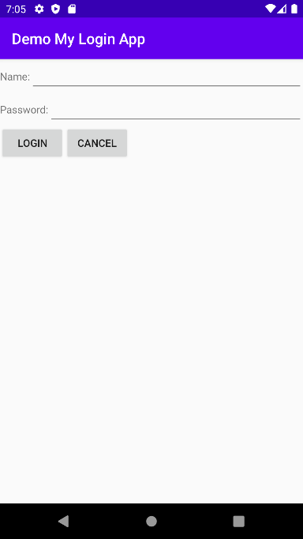

1. How should the main layout be?

|  |
| --- |
| The LinearLayout Orientation should be vertical |

1. Are nested layouts required? Describe how the layout should be designed.

|  |
| --- |
| Yes. The initial LinearLayout of the screen would be in vertical. Another 3 LinearLayout are needed inside the initial one. The other 3 LinearLayout orientation would be in horizontal. This is because, firstly the name requires TextView and Plain Text that are side by side (along the same row) . Similarly for password, the second horizontal LinearLayout is required for TextView and password since there are in the same row. The third horizontal LinearLayout is for the 2 buttons that are in the same row. |

1. Identify the required properties for each UI element:-

|  |  |
| --- | --- |
| **Name** TextView | name |
| Name: |
| **Name** EditText | match_parent |
| wrap_content |
| **Password** TextView | password |
| Password: |
| **Password** EditText | match_parent |
| wrap_content |
| **Login** Button | login |
| Login |
| **Cancel** Button | cancel |
| Cancel |

1. Place the labels of the various UI elements in strings.xml.

|  |
| --- |
| <**resources**>  <**string name="app_name"**>Demo My Login App</**string**>  <string name="name">Name:</string> <string name="password">Password:</string> <string name="login">Login</string> <string name="cancel">Cancel</string>    </**resources**> |

1. Write the XML codes for the layout file.

|  |
| --- |
| <LinearLayout xmlns:android="http://schemas.android.com/apk/res/android"  xmlns:app="http://schemas.android.com/apk/res-auto"  xmlns:tools="http://schemas.android.com/tools"  android:layout_width="match_parent"  android:layout_height="match_parent"  android:orientation="vertical"  tools:context=".exercise2a">   <LinearLayout  android:layout_width="match_parent"  android:layout_height="wrap_content"  android:orientation="horizontal">   <TextView  android:id="@+id/textView2"  android:layout_width="138dp"  android:layout_height="wrap_content"  android:layout_weight="1"  android:text="@string/name"  android:textSize="20sp" />   <EditText  android:id="@+id/editTextTextPersonName2"  android:layout_width="match_parent"  android:layout_height="wrap_content"  android:layout_weight="1"  android:ems="10"  android:inputType="textPersonName" />  </LinearLayout>   <LinearLayout  android:layout_width="match_parent"  android:layout_height="wrap_content"  android:orientation="horizontal">   <TextView  android:id="@+id/textView4"  android:layout_width="15dp"  android:layout_height="wrap_content"  android:layout_weight="1"  android:text="@string/password"  android:textSize="20sp" />   <EditText  android:id="@+id/editTextTextPersonName4"  android:layout_width="wrap_content"  android:layout_height="wrap_content"  android:layout_weight="1"  android:ems="10"  android:inputType="textPersonName" />  </LinearLayout>   <LinearLayout  android:layout_width="match_parent"  android:layout_height="match_parent"  android:orientation="horizontal">   <Button  android:id="@+id/button2"  android:layout_width="101dp"  android:layout_height="wrap_content"  android:text="@string/login" />   <Button  android:id="@+id/button4"  android:layout_width="wrap_content"  android:layout_height="wrap_content"  android:text="@string/cancel" />  </LinearLayout>  </LinearLayout> |

**Exercise 2**

Design and create a registration form. Your design can be different from the registration form given, but should include the required information and be user friendly.

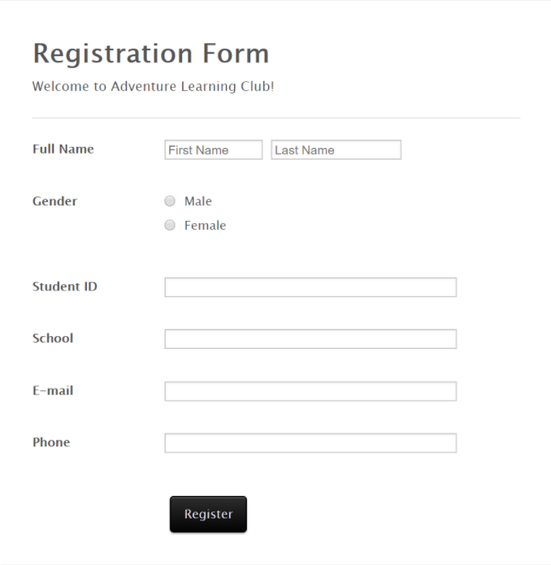

In Android Studio, create a new project with the following information:-

|  |  |
| --- | --- |
| **Project Template** | Empty Activity |
| **Application Name** | Registration App |
| **Package Name** | sg.edu.rp.c346.id<your student ID>.registrationapp |
| **Project Location** | D:\C346\Workspace\P02\RegistrationApp |
| **Language** | Java |
| **Minimum API Level** | API 16 |

**Your screenshot:**

|  |
| --- |
|  |

**activity_main.xml**

|  |
| --- |
| <?xml version="1.0" encoding="utf-8"?> <LinearLayout xmlns:android="http://schemas.android.com/apk/res/android"  xmlns:app="http://schemas.android.com/apk/res-auto"  xmlns:tools="http://schemas.android.com/tools"  android:layout_width="match_parent"  android:layout_height="match_parent"  android:orientation="vertical"  android:background="#405955"  tools:context=".MainActivity">   <TextView  android:layout_width="wrap_content"  android:layout_height="wrap_content"  android:text="@string/text"  android:textAppearance="@android:style/TextAppearance.Large"  android:textColor="#F2F2F2"  android:textSize="30sp"  android:textStyle="bold"  android:layout_gravity="center"/>   <TextView  android:layout_width="wrap_content"  android:layout_height="wrap_content"  android:textSize="18sp"  android:textColor="#F2BEA0"  android:text="@string/message"  android:layout_gravity="center"/>    <View  android:id="@+id/view2"  android:layout_width="458dp"  android:layout_height="2.5dp"  android:layout_marginLeft="2dp"  android:layout_marginTop="2dp"  android:background="#BFBFBF" />    <LinearLayout  android:layout_width="match_parent"  android:layout_height="64dp">   <TextView  android:id="@+id/textView7"  android:layout_width="129dp"  android:layout_height="wrap_content"  android:text="@string/name"  android:textSize="19sp"  android:textStyle="bold"  android:textColor="#F2BEA0"/>   <EditText  android:id="@+id/editTextTextPersonName2"  android:layout_width="144dp"  android:layout_height="wrap_content"  android:backgroundTint="#BFBFBF"  android:ems="10"  android:inputType="textPersonName"  android:text="@string/firstName"  android:textColor="#BFBFBF"  />   <EditText  android:id="@+id/editTextTextPersonName3"  android:layout_width="144dp"  android:layout_height="wrap_content"  android:layout_marginBottom="8dp"  android:backgroundTint="#BFBFBF"  android:ems="10"  android:inputType="textPersonName"  android:text="@string/lastName"  android:textColor="#BFBFBF"  />   </LinearLayout>   <LinearLayout  android:layout_width="match_parent"  android:layout_height="89dp"  android:orientation="horizontal">   <LinearLayout  android:layout_width="129dp"  android:layout_height="35dp"  android:orientation="horizontal">   <TextView  android:id="@+id/textView8"  android:layout_width="136dp"  android:layout_height="wrap_content"  android:layout_weight="1"  android:text="@string/gender"  android:textSize="19sp"  android:textStyle="bold"  android:textColor="#F2BEA0"/>   </LinearLayout>   <LinearLayout  android:layout_width="303dp"  android:layout_height="wrap_content"  android:orientation="vertical">   <RadioButton  android:id="@+id/radioButton"  android:layout_width="match_parent"  android:layout_height="30dp"  android:text="@string/male"  android:textColor="#BFBFBF"/>   <RadioButton  android:id="@+id/radioButton2"  android:layout_width="match_parent"  android:layout_height="30dp"  android:text="@string/female"  android:textColor="#BFBFBF"/>   <RadioButton  android:id="@+id/radioButton3"  android:layout_width="match_parent"  android:layout_height="30dp"  android:text="@string/no"  android:textColor="#BFBFBF"/>  </LinearLayout>  </LinearLayout>   <LinearLayout  android:layout_width="match_parent"  android:layout_height="wrap_content"  android:orientation="horizontal">   <TextView  android:id="@+id/textView3"  android:layout_width="67dp"  android:layout_height="wrap_content"  android:layout_weight="1"  android:text="@string/studentId"  android:textSize="20sp"  android:textStyle="bold"  android:textColor="#F2BEA0"/>   <EditText  android:id="@+id/editTextNumber"  android:layout_width="wrap_content"  android:layout_height="wrap_content"  android:layout_weight="1"  android:ems="10"  android:inputType="number"  android:text="@string/ID"  android:textStyle="italic"  android:textColor="#BFBFBF"  android:backgroundTint="#BFBFBF" />   </LinearLayout>   <LinearLayout  android:layout_width="match_parent"  android:layout_height="wrap_content"  android:orientation="horizontal">    <TextView  android:id="@+id/textView4"  android:layout_width="79dp"  android:layout_height="wrap_content"  android:layout_weight="1"  android:text="@string/school"  android:textSize="20sp"  android:textStyle="bold"  android:textColor="#F2BEA0"/>   <EditText  android:id="@+id/editTextTextPersonName5"  android:layout_width="wrap_content"  android:layout_height="wrap_content"  android:layout_weight="1"  android:ems="10"  android:inputType="textPersonName"  android:textSize="19sp"  android:backgroundTint="#BFBFBF"/>   </LinearLayout>   <LinearLayout  android:layout_width="match_parent"  android:layout_height="wrap_content"  android:orientation="horizontal">   <TextView  android:id="@+id/textView5"  android:layout_width="wrap_content"  android:layout_height="wrap_content"  android:layout_weight="1"  android:text="@string/email"  android:textSize="20sp"  android:textStyle="bold"  android:textColor="#F2BEA0"/>   <EditText  android:id="@+id/editTextTextEmailAddress"  android:layout_width="wrap_content"  android:layout_height="wrap_content"  android:layout_weight="1"  android:ems="10"  android:inputType="textEmailAddress"  android:backgroundTint="#BFBFBF"  android:text="@string/emailex"  android:textColor="#BFBFBF"  android:textStyle="italic"/>   </LinearLayout>   <LinearLayout  android:layout_width="match_parent"  android:layout_height="44dp"  android:orientation="horizontal">   <TextView  android:id="@+id/textView6"  android:layout_width="wrap_content"  android:layout_height="wrap_content"  android:layout_weight="1"  android:text="@string/phone"  android:textSize="20sp"  android:textStyle="bold"  android:textColor="#F2BEA0"/>   <EditText  android:id="@+id/editTextPhone"  android:layout_width="wrap_content"  android:layout_height="wrap_content"  android:layout_weight="1"  android:ems="10"  android:inputType="phone"  android:backgroundTint="#BFBFBF"/>   </LinearLayout>   <LinearLayout  android:layout_width="wrap_content"  android:layout_height="82dp"  android:layout_gravity="center"  android:orientation="horizontal">   <Button  android:id="@+id/button"  android:layout_width="156dp"  android:layout_height="wrap_content"  android:layout_gravity="center"  android:layout_weight="1"  android:backgroundTint="#F2BEA0"  android:text="@string/register"  android:textColor="#405955" />  </LinearLayout>   </LinearLayout> |

**strings.xml**

|  |
| --- |
| <resources>  <string name="app_name">Registration App</string>  <string name="text">Registration Form</string>  <string name="message">Welcome to Adventure Learning Club!</string>  <string name="horizontalLine">------------------------------------------------------------</string>  <string name="firstName">First Name</string>  <string name="lastName">Last Name</string>  <string name="studentId">Student ID:</string>  <string name="school">School:</string>  <string name="email">E-mail:</string>  <string name="phone">Phone:</string>  <string name="name">Full Name:</string>  <string name="gender">Gender:</string>  <string name="female">Female</string>  <string name="male">Male</string>  <string name="no">Prefer not to say</string>  <string name="register">Register</string>  <string name="ID">12345678</string>  <string name="emailex">12345678@myrp.edu.sg</string>  </resources> |